**­CSC 1101 – Problem Solving and Programming Laboratory – Winter 2019**

**Lab 13 – (student name)**

**25 points – Due March 5, end-of-class**

**a)** Save this document with your name and the lab assignment number somewhere in the file name.

**b)** Type/paste your answers into the document.

c) Submit this document and your .cpp file(s) to the Canvas item where you downloaded this document. Do not submit a zip file but individually attach your files.

Create a copy of the C++ template file. Write a C++ console application and do the following:

1. Rename the copy you made to **yourName_InClass_Lab13.cpp** and save it into your *CSC1101* folder.
2. Complete the header comment.
3. Modify the application header and close to contain the application name.
4. Create a value function called **squared** that takes an **integer** as input (parameter) and returns an integer that is the square of the input.
5. Prompt the user for two integers (*num1, num2*).
6. Call function squared for each of the two integers. Store the result of each function call in a separate variable.
7. Print the input and squared values. Format it to look like the sample output.

Sample Output

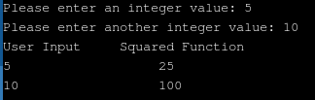

*[your program code here]\**

**//==========================================================**

**//**

**// Title: Squarerer**

**// Course: CSC 1101**

**// Lab Number: Lab 13**

**// Author: Trevor Trusty**

**// Date: 3/5/2019**

**// Description:**

**// Takes two integers as input and returns both values**

**//squared to the user.**

**//**

**//==========================================================**

**#include <conio.h> // For function getch()**

**#include <cstdlib> // For several general-purpose functions**

**#include <fstream> // For file handling**

**#include <iomanip> // For formatted output**

**#include <iostream> // For cin, cout, and system**

**#include <string> // For string data type**

**using namespace std; // So "std::cout" may be abbreviated to "cout"**

**//Square Function**

**int squared(int x)**

**{**

**return x * x;**

**}**

**//Global Constants**

**int C1 = 15;**

**int C2 = 20;**

**int main()**

**{**

**int num1, num2;**

**// Declare variables**

**// Show application header**

**cout << "Welcome to my Application!" << endl;**

**cout << "--------------------------" << endl << endl;**

**// Read from console**

**cout << "Enter two integers to be squared!\n";**

**cout << "Integer 1: ";**

**cin >> num1;**

**cout << "Integer 2: ";**

**cin >> num2;**

**cout << endl;**

**// Write to screen**

**int result1 = squared(num1);**

**int result2 = squared(num2);**

**cout << setw(C1) << left << "User Input";**

**cout << setw(C2) << right << "Squared Function" << endl;**

**cout << setw(C1) << left << num1;**

**cout << setw(C2) << right << result1 << endl;**

**cout << setw(C1) << left << num2;**

**cout << setw(C2) << right << result2 << endl;**

**// Show application close**

**cout << "\nEnd of my Application" << endl << endl;**

**// Pause before application window closes**

**cout << "Press any key to exit ..." << endl;**

**_getch();**

**}**

*[your program output here]\*\**

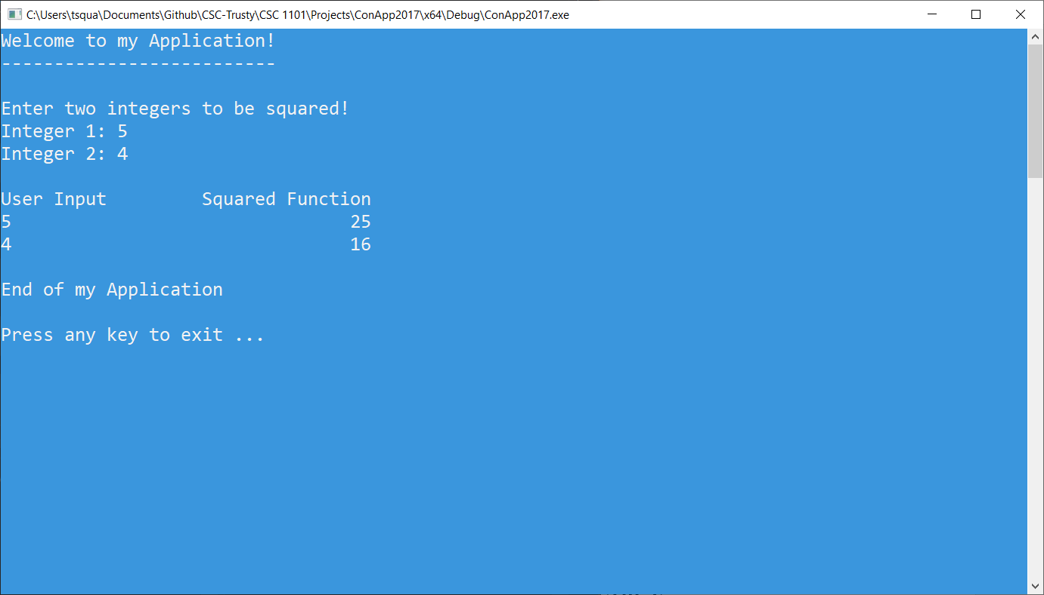

* **Copying-and-pasting Visual C++ code to a Word document**

1) From within the Visual C++ program, press **CTRL-A** and press **CTRL-C**.

2) From within the Word document, press **CTRL-V**.

** **Copying-and-pasting Visual C++ console application output to a Word document**

1) From the Visual C++ console, press **ALT-PrintScreen**.

2) From within the Word document, press **CTRL-V**.